Motion Studies Basic Digital Photography

Be sure you have your camera set correctly for this portion of the shoot!

Camera Mode: TV
Shutter Speed: Set for the type of shot you are taking!
F-Stop: Should not be blinking
ISO: As low a number as you can go for the lighting situation you are in!
Focus: AF
HOLD STILL!
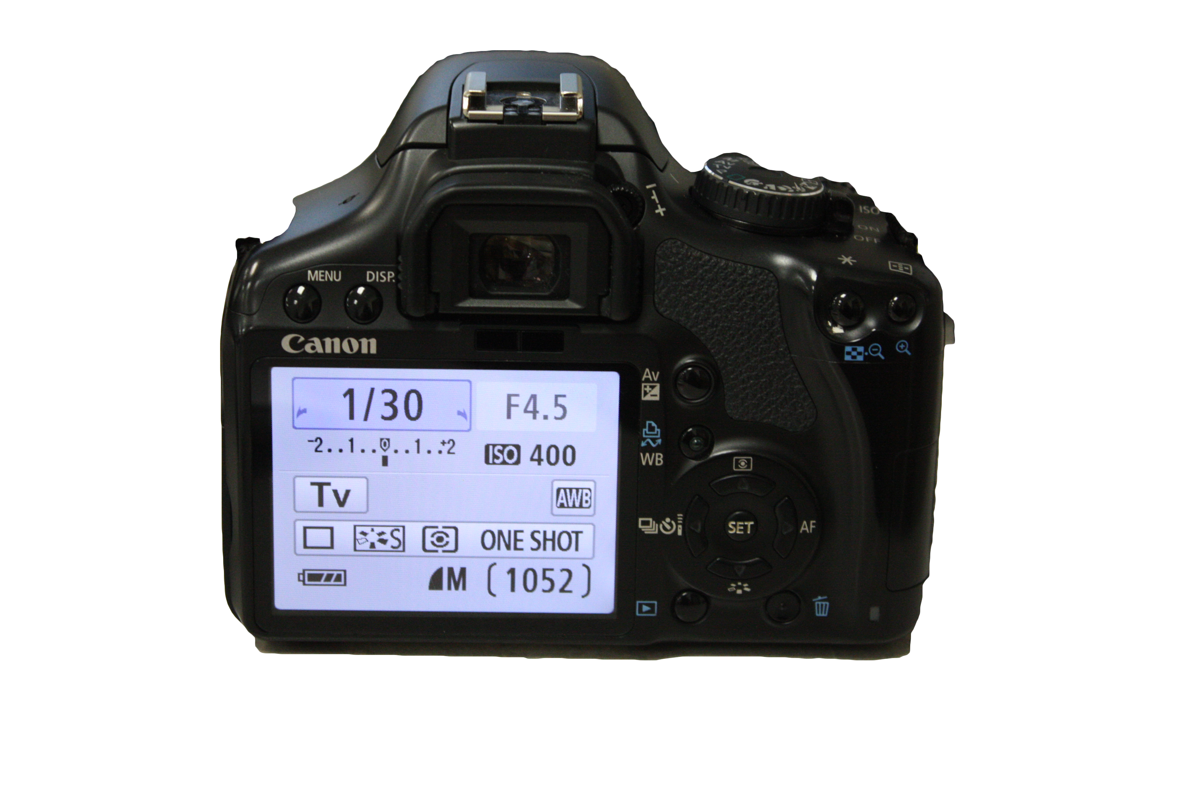

In class: 10 Images
Use EACH backdrop to create some kind of well-lit motion
1-GOOD Blur @ each backdrop
1-GOOD Stop Action @ each backdrop
**A portrait must be used with motion on the BLACK BACKDROP**

Out of Class: 14 Images
Panning- 1/30 of a second shutter speed
2-Linear (follow with your camera in a line)
2-Pull (twist your ZOOM in or out while shooting)
2-Twist (twist your CAMERA while shooting)
2-Spin (hold an object out and spin while shooting)

Blur- 1/30 of a second shutter speed
1-Someone spinning (from ABOVE)
1-Someone dancing (just their feet)
1-Someone moving and object (close up of hands)

Stop Action 1/250 of a second shutter speed
1-Someone jumping (from below)
1-Someone jumping (just feet)
1-Someone tossing an object (close up of hands)

